In this in-class project you will create a console C++ program that will have the user enter Celsius temperature readings for each day of the week and then display a report showing both the Celsius and Fahrenheit temperatures for each day entered. This program requires the use of arrays.
- You will collaborate in groups of 2 to 3 students, but each of you will write your own program on your own laptop. You will be submitting your source code at the end of the lesson for marks.
- You must be present, in class, to be eligible to participate in the activities, and thus be eligible for these marks.

Getting User Input
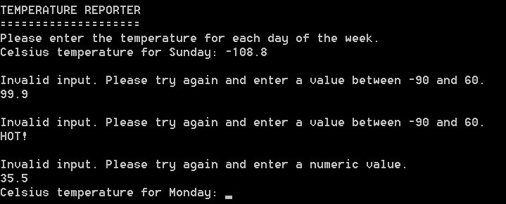
Prompting: For this lab, rather than prompt the user “Enter temperature for Day 1: “, use the actual day in the prompt, e.g. “Enter the temperature for Sunday: “. You are required to use a loop to get user input.
Converting an Integer to a Day String: Write a function that will accept an integer as an argument and return a string. If the argument is in the range 1 to 7 inclusively, return the corresponding name for the day. For example, an argument of 1 should return “Sunday”, an argument of 2 should return “Monday”, etc. Although you could use an if-else chain or a switch, the trick to doing this very efficiently is to implement an array of strings that contains the names of the days as elements and to use the argument as an index to find the right day. If the argument is outside of the range 1 to 7, return an error message instead.
Range Validation: The lowest natural surface temperature on Earth is −89.2°C. It was measured on 21 July 1983 at Vostok Research Station in the Antarctic. The highest surface temperature recorded is 57.8°C, in ‘Aziziya, Libya on 13 September 1922. Given these values, the temperatures the user enters should fall between the range -90.0°C and +60.0°C. Do not accept an input value outside of that range.

Displaying the Temperature Report
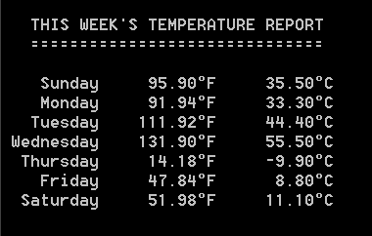

Processing: Converting Celsius to Fahrenheit
To generate the required output, you will need to convert each Celsius temperature to Fahrenheit. Given this is a fairly generic task that could be re-used in another program, you should create a function to do this. The actual calculation is straight forward; the function body may only need to be one line of code, so the function should be ‘inline’. Keep in mind that a processing function should only do processing, not input or output. Pass the Celsius temperature in as a parameter and send the Fahrenheit temperature back using a ‘return’ statement.

Output: This Week’s Temperature Report
Write a function template that will display the temperatures entered in Celsius and Fahrenheit formatted as above. You must pass this function at least the array storing the Celsius temperatures and the number of items in that array. You could pass an array containing Fahrenheit temperatures although it is more efficient to simply call your processing function to convert each individual temperature as you need it. Either way is acceptable.
Formatting Hints:
- Look up the ASCII code value for the degrees symbol.
- Each ‘column’ of the report is right aligned ten characters wide.

General Requirements
- Include an opening comment with your full name, the full names on the student(s) you are working with, the name of the program, the date, and a short description.
- Follow the style guide! Use descriptive names and sensible data-types for variables, constants, arrays, functions, etc. that follow our naming conventions. Use good spacing and make sure braces ({}) are located where they are supposed to be.
- Attach the unzipped source code file(s) (.cpp, .h) to the dropbox. Nothing else please.

http://en.wikipedia.org/wiki/Vostok_Station
http://en.wikipedia.org/wiki/%27Aziziya

